Current EVA Domain Assistant Reference Architecture

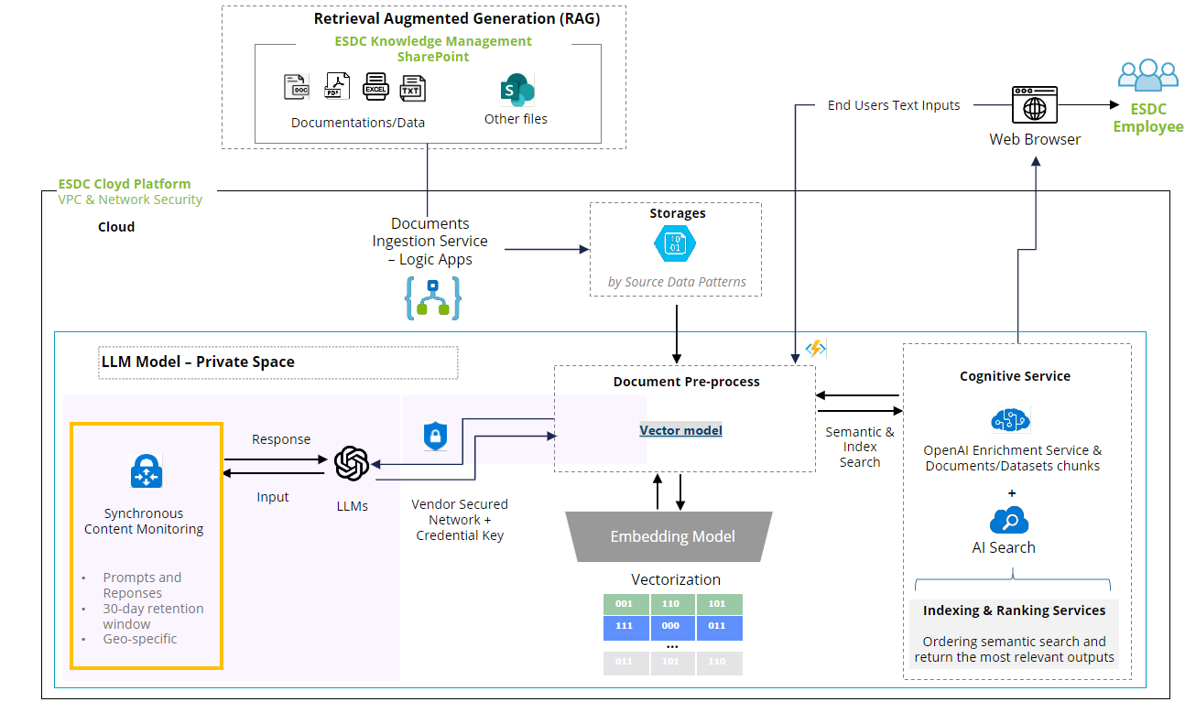

What’s Strong and Valuable
Strength | Description
RAG Lifecycle Clarity | It shows the full flow from ingestion to vectorization, semantic search, and LLM response generation.
Separation of Components | Divides responsibilities between ingestion, storage, vector models, and cognitive services.
Privacy and Monitoring | Shows synchronous content monitoring and 30-day prompt retention — key for governance discussions.
Tech Stack Hints | Mentions Logic Apps, Azure Storage, OpenAI Enrichment, and SharePoint — giving infrastructure context.
End-to-End Traceability | Covers document ingestion to employee interaction through browser UI.

🔁 What Could Be Added or Tweaked
Area | Suggestion
Governance + Trust Layer | Add an overlay for: audit logging, CSAT/QA routing, trust evidence export to MTP.
API Entry Points | Show AssistMe or 3rd-party apps calling the RAG services via secured API endpoints.
Service Metadata | Annotate components with metadata flows: model name/version, EndpointID, OrchestrationSessionID.
Rules as Code | Add an optional Rules Engine box (e.g., Blawx, JSONLogic) next to “Cognitive Service” to reflect evolving capabilities.
Feedback Loop | Add a line from “LLM Response” to a box for Tier 1 and Tier 2 CSAT/QA evaluation feeding back into MTP.
Cost Monitoring | Overlay token usage tracking for cost recovery visualization — tied to user/caller context.

